Capital Market Technology Lab Report
FIX Trading Simulator with Order Cache Optimisation
Group 9
Name- Anoushka Rajvanshi
Reg. no.- 230958010
1. Introduction
One cannot ignore the fact that there have been tremendous technological changes in the development of the financial markets. Modern infrastructure requires a great deal of throughput capabilities along with fault tolerance. Therefore, the proposed project, named “FIX Trading Simulator” intends to emulate a realistic trading scenario between a Broker and a Stock Exchange based on the use of the Financial Information eXchange (FIX) protocol.
The Financial Information Exchange (FIX) protocol is an internationally accepted standard for messages used in real-time electronic communication in financial markets. It provides an opportunity to create an effective dialogue between financial institutions including brokers and exchanges. For this project, the use of QuickFIX/J will be considered an effective way to understand the communication process among various trading systems.
In terms of technical architecture, the proposed project will use microservices technology with the following tools used for different purposes: Quarkus for backend, Angular for frontend, PostgreSQL for storing data, and Docker containers for implementation.
Another important aspect that needs to be considered as a focus area in this project is that of performance optimization. In a practical scenario, accessing databases in any trading system frequently may have an effect on latency and throughput. For this purpose, the Order Cache module was added to the existing system, providing in-memory caching support.
This document presents an overall description of how the architecture and implementation of the system were improved due to the use of the Order Cache module.

2. Objectives of the Project
The main goal of the current project is the development of a trading simulator to emulate the communication process between the broker and the stock market through the use of the FIX protocol. It should be noted that the project's goals include the connection of theoretical concepts and their practical implementation through exposure to real-world components of a trading system.
One of the key goals is to study the process of managing the order life cycle in financial systems, including its placement, execution, modification, and cancellation. Moreover, the project will be oriented toward real-time communication through the use of WebSockets and RESTful API.
Improving the performance of the system is another important goal of the project. In particular, the in-memory order caching will reduce the load on the database, increase speed, and improve data access. It should be highlighted that the development project includes the practical application of modern development tools, including Docker, PostgreSQL, and Angular.

3. System Overview
There are two main systems involved in the FIX Trading Simulator – the Broker system and the Exchange system. They use the FIX protocol to communicate with each other.
The Broker system functions as the front-end where traders are allowed to place orders. There is a Quarkus-based back-end along with the Angular-based front-end in it. The back-end is responsible for communicating with the Exchange system using the QuickFIX/J protocol, whereas the front-end uses REST API and WebSockets to interact with the back-end.
The role of the Exchange system is to act as a matcher. It receives the order, matches them and delivers the execution reports back. The Exchange system contains a back-end built with Quarkus and the Angular-based front-end as well.
They both make use of the same PostgreSQL database which is responsible for persisting and logging all information such as order details, sessions data, and FIX messages.
The entire system uses Docker to deploy the application, making it possible to be scaled. The Docker Compose approach was chosen for orchestrating the whole setup.

4. System Architecture
The architecture of the system follows a distributed microservices approach. Each component is designed to handle a specific responsibility, ensuring modularity and scalability.
4.1 Exchange Back-End
Backend part of Exchange is implemented in Quarkus and serves as FIX Acceptor. It accepts FIX connections from Broker, which initiates trading requests. Order matching, execution, and order book management functionality is included in Exchange backend.
4.2 Broker Back-End
Backend part of Broker system is also implemented in Quarkus, however, it serves as FIX Initiator. It connects to Exchange backend and sends trading requests like orders submission and cancelation.
4.3 Front-End Applications
Frontend of both Broker and Exchange applications is implemented in Angular framework and provides graphical user interface for accessing system and viewing order information, sessions state, logs, etc.
4.4 Database Layer
PostgreSQL database is used as storage for all persistent information – orders, FIX messages, session logs, etc.
4.5 Communication Layer
System communicates using several protocols:
• FIX – for communication between backends
• REST API – for communication between frontends and backends
• WebSockets

5. Features of the System
The trading simulator includes several important features that replicate real-world trading environments.
5.1 Order Management
A user can place an order, change an order, cancel an order, and view an order. The system is designed to provide real-time support by reflecting any changes instantly within the system components.
5.2 Session Management
Login and logout from a FIX session are supported within the system along with the ability to see sessions and messages.
5.3 Logging and Monitoring
The system logs all FIX messages and events. This feature allows analyzing messages to debug problems.
5.4 Real-Time Updates
WebSockets are used to synchronize order statuses with frontend immediately when changes happen.

6. My Contribution: Order Cache and Performance Optimisation
In addition to implementing the main components of this system, I have worked to improve performance via the development of an in-memory order caching system.
6.1 Need for Caching
Frequent database interactions in high-frequency trading become a performance issue. Every order manipulation action involves accessing the database. To optimize the system, in-memory caching technology was employed to speed up the process.
6.2 Design of Order Cache
The design of the cache involves storing of orders using multiple attributes to facilitate efficient searching. The indexing methods are as follows:
• By Symbol: Facilitates easy access to all orders for a specific stock symbol.
• By Client: Helps track the orders from the same client.
• By Status: Makes it possible to filter orders depending on the status (pending, completed, cancelled).
The cache relies on data structures such as hash maps to enable fast and efficient operations.
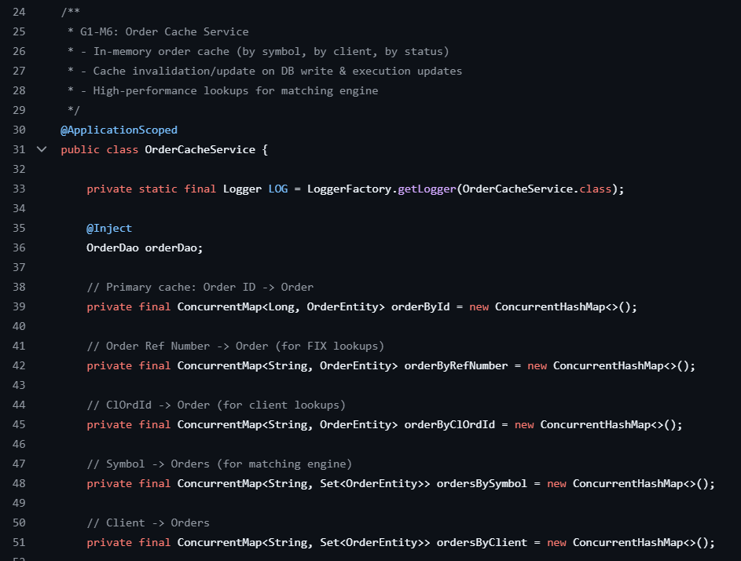
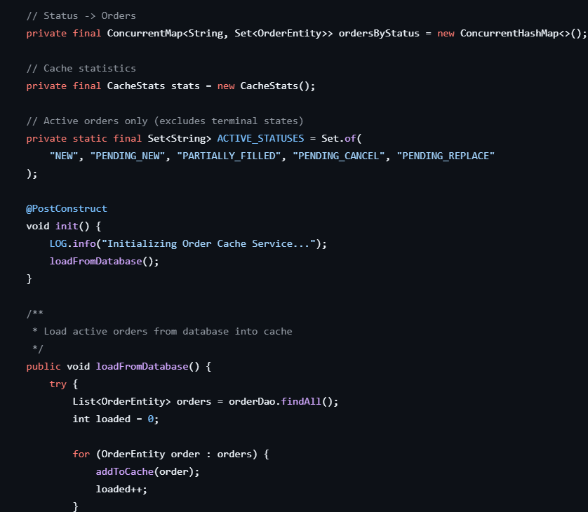

6.3 Cache Update and Invalidation Strategy
Data consistency is one of the major challenges associated with caching. In order to ensure that the cache contains consistent data, the following measures have been put in place:
• Write-Through: When writing data into the database, it is written in the cache as well.
• Updates during Order Execution: Updating of the cache each time an order is executed or changed in any way.
• Invalidation Process: Removal of the data from the cache in case it is invalid.
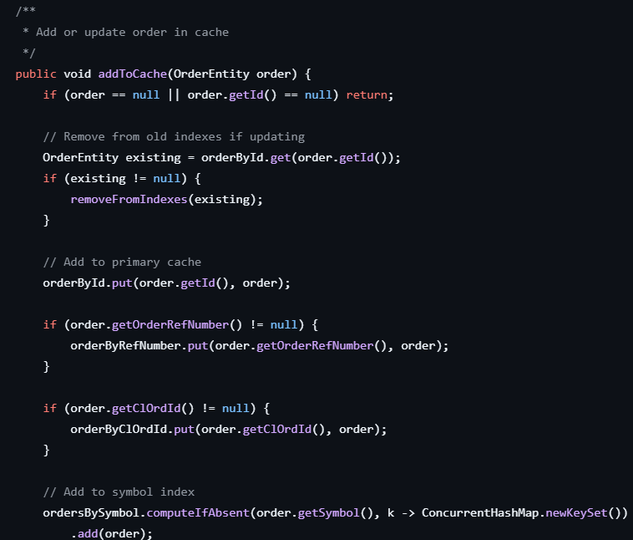
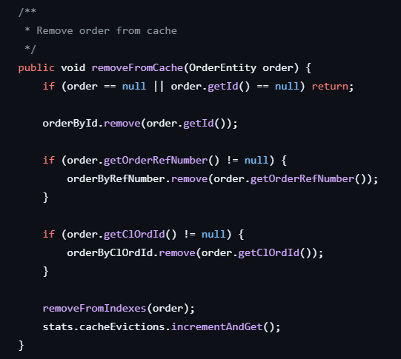

6.4 Performance Testing
Load testing was used to measure the efficiency of the cache mechanism. The following indicators were considered during the test:
• Throughput: number of orders completed per second
• Latency: duration of each request processing
• Load on the database: number of database queries before and after the use of caching
Significant improvements in the performance were noted, as the number of database hits decreased, as well as the time required for requests.

7. Running the Project
The application can be deployed using Docker Compose tool. Once the services are up and running, the following components will be available:
• Broker Frontend
• Broker Backend (Swagger UI)
• Exchange Frontend
• Exchange Backend (Swagger UI)
• PostgreSQL Database
Alternatively, the project can be launched manually.

8. Challenges Faced
In the course of the project implementation, some difficulties had emerged. The first one is related to synchronization and maintenance of integrity between the cache and the database. Inconsistency could have resulted in erroneous order information display.
The second difficulty concerns parallel updates, as multiple orders can be updated at the same time. Appropriate synchronization techniques should be utilized to avoid a race condition.
Moreover, coordination between different technologies, including FIX protocol, REST APIs, WebSockets, and Docker had to be performed carefully.

9. Conclusion
The FIX Trading Simulator project presents a practical example of the work of a modern financial market trading system implemented with relevant technologies. It is very helpful in terms of getting familiar with brokers and exchange interactions with the help of the FIX protocol.
The Order Cache implementation has greatly improved the system performance and reduced latency by decreasing the dependence on the database. This shows the importance of the application of optimization techniques in finance.
To sum up, the project contributed to gaining deeper insight into modern technologies of distributed systems and financial market.

10. Future Enhancements
Future improvements can include:
- Advanced order matching algorithms
- Risk management features
- Distributed caching using Redis
- Scalability using Kubernetes
- Enhanced UI/UX for better user experience

